**23CSE111**

**LAB MANUAL**



**Department of CSE**

**Amrita School of Engineering**

**Amrita Vishwa Vidyapeetham, Amaravati Campus**

**Verified By :- Name: G.lakshmi karthikeya**

**Roll No: 24049**

|  |  |  |  |  |
| --- | --- | --- | --- | --- |
| S.NO | Programs | Date | Pg:No | Signature |
| 1 | 1. Download and Install Java Software. 2. Write a java program to print message “Welcome to java programming”. 3. Write a java program that prints name,roll number,section of a student. |  |  |  |
|  |  |  |  |  |
|  |  |  |  |  |
|  |  |  |  |  |
|  |  |  |  |  |
|  |  |  |  |  |
|  |  |  |  |  |
|  |  |  |  |  |

Week 1:-

# Program-1:-

## Aim:-Download and Instal the Java Software Procedure Step-1:- Type Java download in search

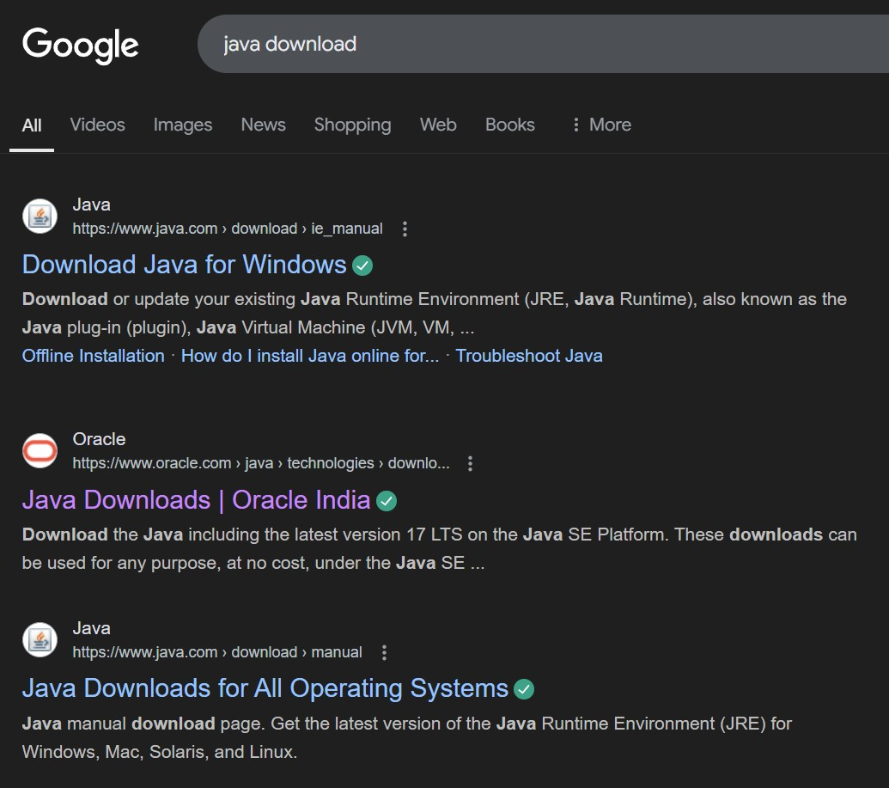

## Step-2:-click on oracle java download and enter into oracle website

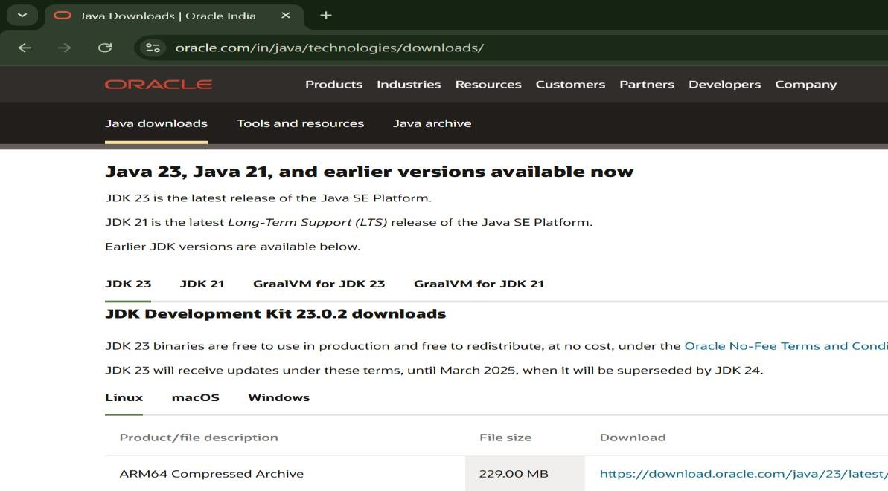

## Step-3:-click on JDK21 and click on windows and later click on x64 instalier link to download

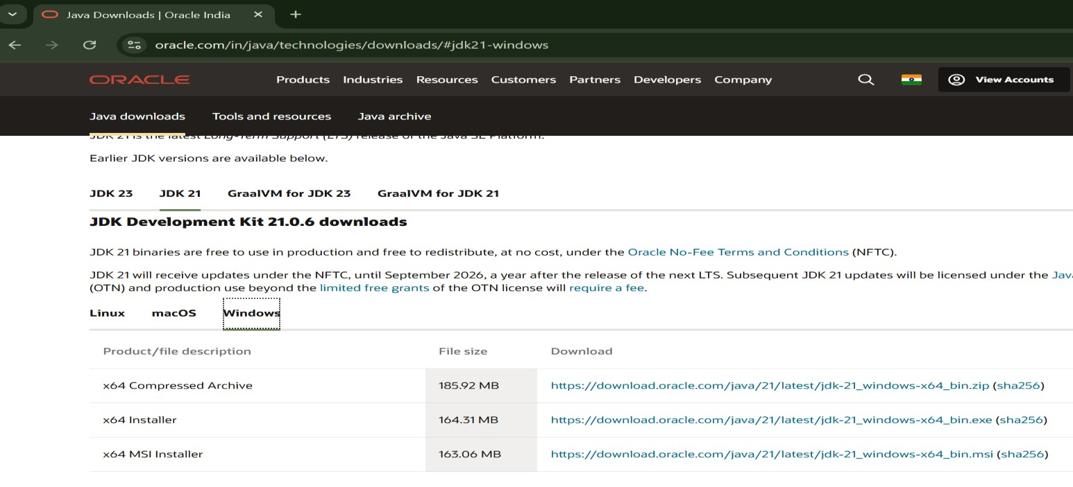

## Step-4:-After completing download click on it’s file and then give permission to install

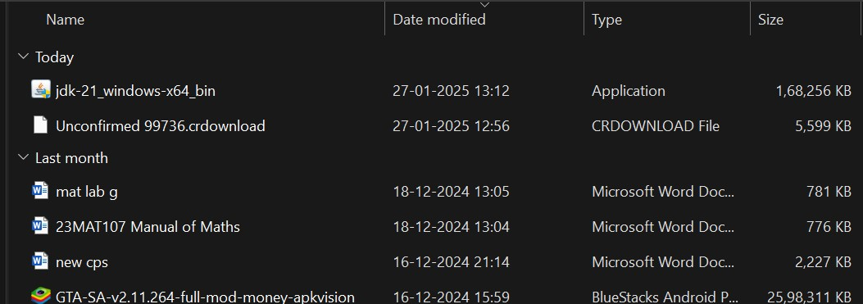

Step-5:-Then go to (This pc) in that click (windows{c}) in that click (Program files) in that click (Java) in that click (jdk-21) in that click (bin)

## Step-6:-Select and copy path of opening the file and then press windows and search System Environmental

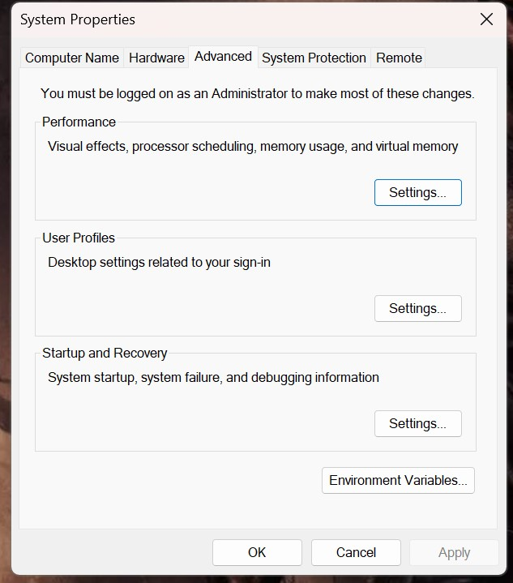

Step-7:-After opening Environment variables then past path of opening file in user variable and click on ok

## Step-8:-To verify version open CMD and type java --version

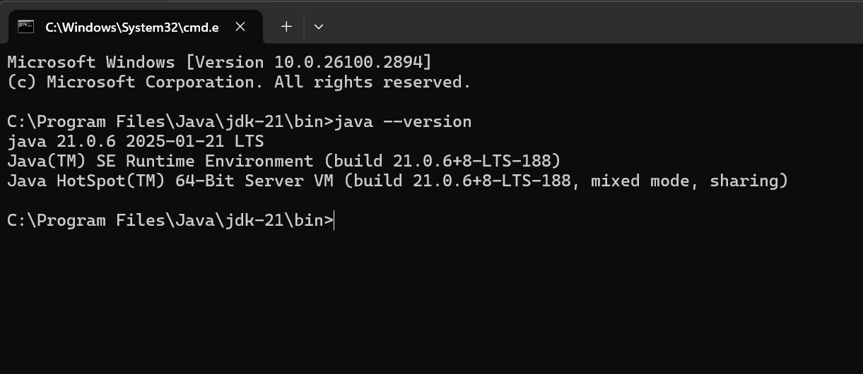

**Program : 2**

## Aim:-write a java program to print[welcome to java programming Input:-

class ex_1{

public static void main(String[] args){

System.out.println("welcome to java programming");

}

}

## Output:-

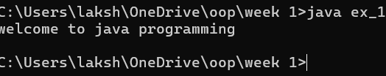

### Program : 3

Aim:-write a java program that prints name, roll no, section of the student Input:-

class Studentdet{

public static void main(String[] args){

System.out.println("Name: G.l.karthikeya”);

System.out.println("Class: CSE A");

System.out.println("Roll No: 24049");

}

}

### Output:-

